1. Write a C program to add two integers.

Input: get two variables as input say a,b;

Process : c=a+b;

Output: store the answer in the variable c;

Program:

#include<stdio.h>

void main()

{

int a,b,c;

scanf("%d%d",&a,&b);

c=a+b;

printf("%d",c);

}

Example a=5,b=10;

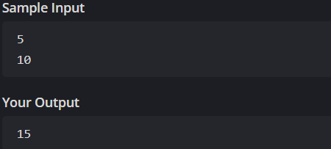

2. Write a program to swap two numbers using a temporary variable.

Intput : take two number as an input say a,b;

Process: now temp=a;

a=b;

b=temp;

output : is swapping of the of the give two input

example a=6 b=7;

program:

#include <stdio.h>

void main()

{

int a = 5, b = 10, temp;

temp = a;

a = b;

b = temp;

printf(" a = %d, b = %d\n", a, b);

}

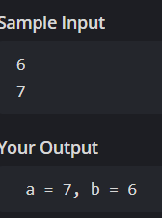

3. Write a program to swap two numbers without using a temporary variable.

Input: take two number as an input say a,b;

Process: now

a=a+b;

b=a-b;

a=a-b;

output: swapping of the given number without using a 3rd variable;

#include <stdio.h>

void main()

{

int a = 4, b = 6;

a = a + b;

b = a - b;

a = a - b;

printf(" a = %d, b = %d\n", a, b);

}

Example a=4,b=6;

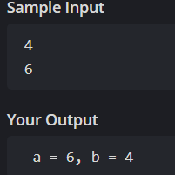

4. Write a program to find the ASCII value of a character.

Input : take any letter in English alphabet in upper case or lower case;

Process : take a character as input and assign the character to an integer n

n=ch;

output: you will get an number for each character

example if you take a ascII value is 97

program:

#include <stdio.h>

int main()

{

int n;

char ch;

scanf("%c",&ch);

n=ch;

printf("%d",n);

}

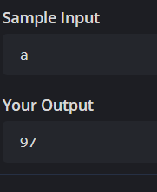

5. Write a program to calculate the area and perimeter of a rectangle.

Input : take input a two values that is length and breadth of the retangle l,b

Process: perimeter=2x(l+b);

Otput : perimeter of the rectangle; example l=5,b=4

Program:

#include<stdio.h>

void main()

{

int l,b,p;

scanf("%d%d",&l,&b);

p=2\*(l+b);

printf("%d",p);

}

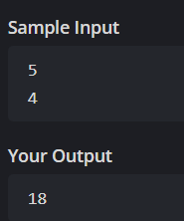

6. Write a program to compute the simple interest.

Input: get the input values r,t,p

Process : simple interest = pxtxr/100;

Output simple interest for given data;

Example p=500,t=4,r=3

Program:

#include<stdio.h>

void main()

{

int p=500,t=4,r=3,si;

si=p\*t\*r/100;

printf(" simple interest=%d",si);

}

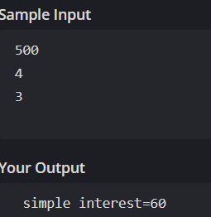

7. Write a program to convert temperature from Celsius to Fahrenheit.

Input : take the input temperature in Celsius

Process: convert the Celsius temp in Fahrenheit

By f=cx9/5+32;

Ouput : temperature in Fahrenheit;

Example c=25

Program:

#include<stdio.h>

void main()

{

int c=25,f;

f=c\*9/5+32;

printf(" temp in fahrenheit=%d",f);

}

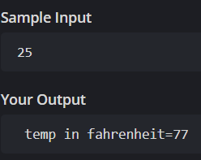

8. Write a program to find the quotient and remainder of two integers.

Intput : take two values which is a,b

Process : for reminder=a%b;

For quotient=a/b;

Output: the quotient and reminder of the given two number;

Program:

#include <stdio.h>

int main()

{

int a, b;

;

scanf("%d %d", &a, &b);

if (b == 0) {

printf("Division by zero error.\n");

}

printf("Quotient = %d\nRemainder = %d\n", a / b, a % b);

}

Example a=25,b=5;

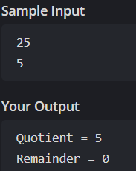

9. Write a program to check whether a number is even or odd.

Input : take an integer x as an input;

Process : if n is exactly divisible by 2 then the given number is even else the given number is odd

Output : whether the given number is odd or even;

Program:

#include <stdio.h>

int main()

{

int x;

scanf("%d", &x);

if (x%2 == 0)

printf("even number");

else

printf("odd number");

}

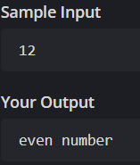

10. Write a program to calculate the square and cube of a number.

Input: take the values of the base and power b,p;

Process : pow(b,p);

Output: square of the number and cube of the number

Example : 2

Program:

#include <stdio.h>

#include <math.h>

int main()

{

int b = 2, p = 2;

printf(" square of the given number = %.0f\n", pow(b, p));

p=3;

printf(" cube of the given number = %.0f",pow(b,p));

}

